SQL QUERIES WITH OUTPUT:

-- 1. Basic query to get all movies with rating above 8.5, ordered by rating

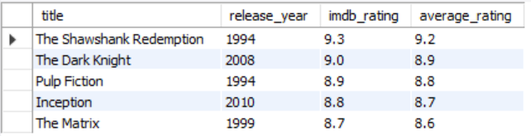

-- 2. Find all TV shows with their season count

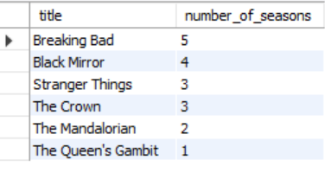

-- 3. Get the top 10 most watched content based on viewing history

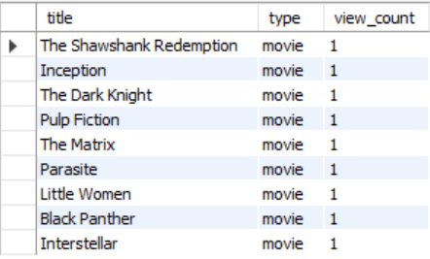

-- 4. Get all content in a specific genre (Drama)

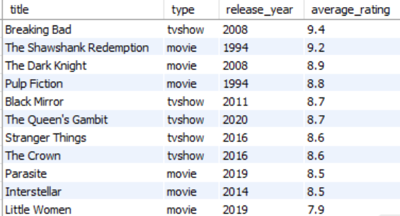

-- 5. Find all actors who have worked with a specific director (Christopher Nolan)

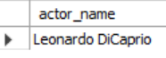

-- 6. Calculate the average watch time per content type



-- 7. Find users who have watched content but haven't left a review

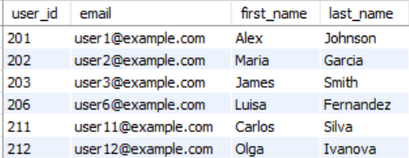

-- 8. Get subscription revenue by plan type

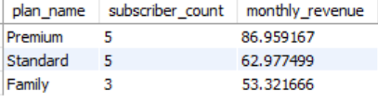

-- 9. Find the most popular devices used for streaming

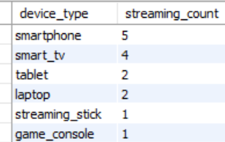

-- 10. Get viewing activity by country

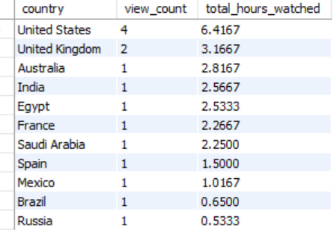

-- 11. Find content that appears in multiple users' watchlists

